Lab 8

Example

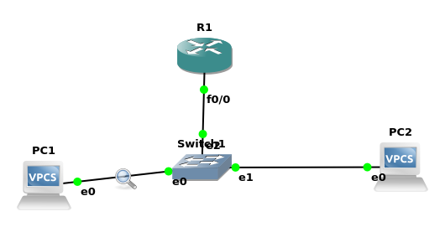

Configuring DHCP (R1)

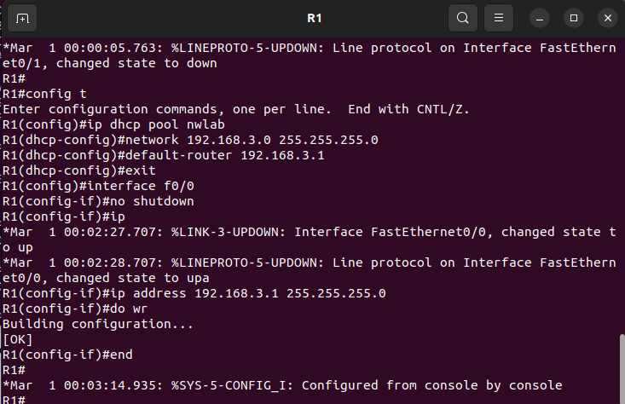

Turning on PC1

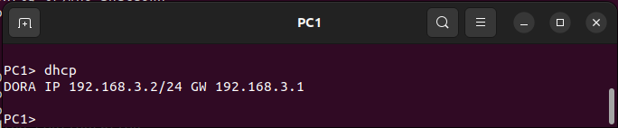

Capturing on wireshark

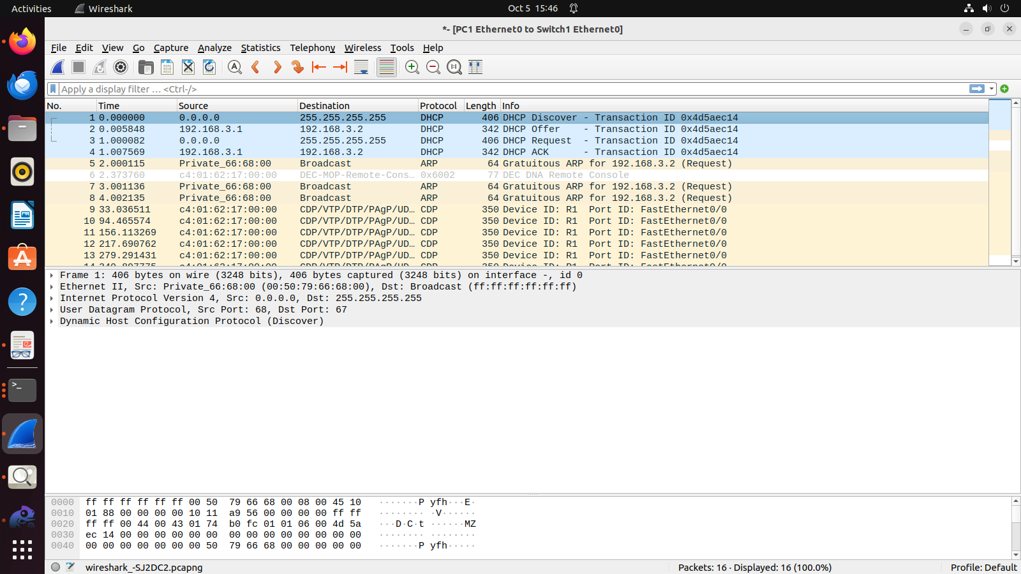

We can notice DHCP Discover, Offer, Request and ACK I.e. DORA on the wireshark

Class Question

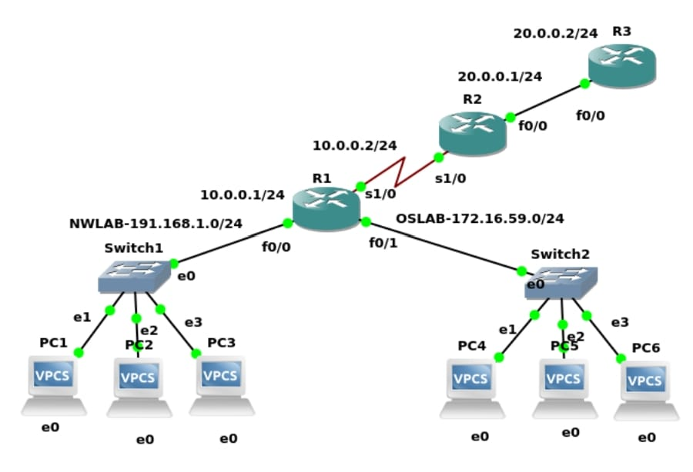

Configurations

R3:

R3#conf t

R3(config)#ip dhcp pool nwlab

R3(dhcp-config)#network 191.168.1.0 255.255.255.0

R3(dhcp-config)#default-router 191.168.1.254

R3(dhcp-config)#ip dhcp pool oslab

R3(dhcp-config)#network 172.16.59.0 255.255.255.0

R3(dhcp-config)#default-router 172.16.59.254

R3(config)#inter f0/0

R3(config-if)#ip address 20.0.0.2 255.255.255.0

R3(config-if)#no shutdown

R3(config-if)#exit

R3(config)#ip route 191.168.1.0 255.255.255.0 20.0.0.1

R3(config)#ip route 172.16.59.0 255.255.255.0 20.0.0.1

R2:

R2#conf t

R2(config)#inter f0/0

R2(config-if)#ip address 20.0.0.1 255.255.255.0

R2(config-if)#ip helper-address 20.0.0.2

R2(config-if)#no shutdown

R2(config-if)#exit

R2(config)#ip route 20.0.0.0

R2(config)#ip route 20.0.0.0 255.255.255.0 20.0.0.2

R2(config)#ip route 191.168.1.0 255.255.255.0 10.0.0.1

R2(config)#ip route 172.16.59.0 255.255.255.0 10.0.0.1

R1:

R1#conf t

R1(config)#inter s1/0

R1(config-if)#ip address 10.0.0.1 255.255.255.0

R1(config-if)#no shutdown

R1(config-if)#ip helper-address 20.0.0.2

R1(config-if)#exit

R1(config)#inter f0/0

R1(config-if)#ip address 191.168.1.254 255.255.255.0

R1(config-if)#no shutdown

R1(config-if)#ip helper-address 20.0.0.2

R1(config-if)#exit

R1(config)#inter f0/1

R1(config-if)#ip address 172.16.59.254 255.255.255.0

R1(config-if)#no shutdown

R1(config-if)#ip helper-address 20.0.0.2

R1(config-if)#exit

R1(config)#ip route 20.0.0.0 255.255.255.0 10.0.0.2

R1(config)#do wr

